

Ben-Gurion University of the Negev

Faculty of Engineering Science

School of Electrical and Computer Engineering

Dept. of Electrical Engineering

Finals Year Engineering Project

PDR

Unmanned Surface Vehicle for Searching and Survey of shallow water bodies

|  |  |
| --- | --- |
| **p-2023-115** | **Project ID** |
| **Yuval Avigdor – 203387097**  **avigdory@post.bgu.ac.il**  **Yonatan Axelrad – 311366249**  **axelray@post.bgu.ac.il** | **Students** |
| **Hugo Guterman** | **Supervisor** |
| - | **Sponsors** |
|  | **Submission date** |

Key words: Side scan sonar, ASV, ROS, Seabed scanning, Remote Sensing.

**Abstract:**

Water reservoirs come in all shapes and sizes and with a variety of different types of water. Our project will focus mainly on shallow freshwater bodies such as fish pools, lakes and drinking water reservoirs. We will of course keep in mind the fact that may of these bodies of water have some sort of interference factors like water pumps and muddy water.

Improving upon our ability to search the underwater surface has been a goal for many companies in recent years. The uses are numerous. for example:  
1. Finding and retrieving military equipment and tech.  
2. Assisting law enforcement in locating human bodies or stashed items on the bottom of water bodies.  
ETC.

Our goal in this project is to integrate multiple systems and sensors onto a Kayak in order for it to be able to manage a variety of assignments.  
The vehicle must be able navigate itself to predetermined waypoints using real time data from an onboard GPS system, it must scan the underwater surface while moving and record all the data it gathered. The project will be using principals that are implemented in autonomous tools specifically designed to water reservoirs.

The solutions provided today in the submarine industry, mostly use systems which record data and are only able to transfer the data at the ed of a run, mainly because of bandwidth limitations of an acoustic modem. Some also use a long cable which offers its own limitations.

The solution we propose is an autonomous vehicle (Kayak), that would transmit in real-time all the data from sensors such as GPS, magnetometer, sonar and a camera. The transmission will be based on WIFI communication for most sensors (Sonar, Camera etc.), and we'll add a LoRa communication to ensure a line of basic telemetry.

Having all the data transferred to an operator in real-time will enhance the chances of mission success. It will save time in instances where the operator sees the object in real time and the system won't have to scan the entire surface, and we could also get a more thorough scan using an autonomous system following full predetermined routes.

**תקציר**

**List of specifications**

Detection and Mapping of underwater surface in real time by autonomous Kayak.

A special sealed chamber will be designed and manufactured for the sonar to be placed in. The chamber, in turn, will be placed under the Kayak. It is important that we monitor the environment inside the chamber in order to alert the user if there's any trouble in regard to pressure, humidity or temperature inside the chamber.

The Kayak will have two cameras mounted on it. One below water and one above, in the front part of the Kayak to provide more angles for the operator.

The Kayak will also be mounted with a main chamber where the electronic systems and the computer will be placed. We will use the UP ™ board computer and we'll run ROS2 to manage all operations and communications between the separate units of the Kayak. Code will be written in Python.

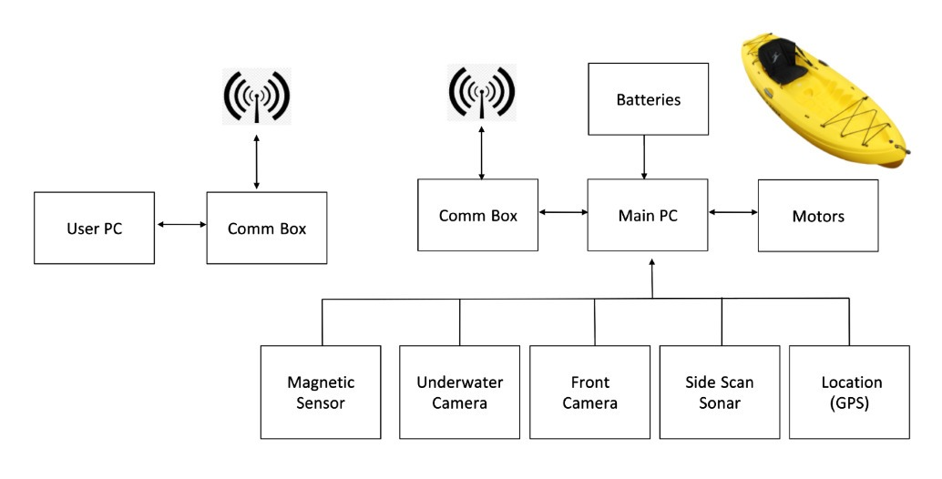

* Batteries: Lithium based batteries.
* Motors: Two Torqeedo Ultralight 403A Pylon motors
  + Max. input power 400W
  + Max. propulsive power 180W
  + Total weight 8.8kg.
* Computer: UP Board series
  + Intel® ATOM™ x5-Z8350 Processors 64 bits up to 1.92GHz.
  + 4GB DDR3L RAM
  + 64GB eMMC.
* Cameras - Flea3-GE:
  + Front Camera: In order to define border limits (coastline).
  + Underwater Camera: Scan the area below the kayak to find to detect objects.
  + 1.3MP image.
  + 31FPS at 1288x694.
* Location: GPS sensor (NEO-M8N) for real time position and navigation system.
  + Update rate up to 10 Hz.
* Side Scan Sonar:  Klein UUV-3500, survey the underwater surface, (see figure 1).
  + Operation frequencies - 455 kHz, 900 kHz.
  + Beam width - horizontal: 0.34°, vertical: 45°.
  + Typical range - 150 m @ 455 kHz, 75 m @ 900 kHz.
* Communication Box - RF modems for transmitting data and telemetries between the kayak and the operator on shore:
  + WIFI - bit rate up to 150Mbps @ 2.4GHz.
  + Lora SX1276 - bit rate up to 1.4kbps @ 433MHz.
* Magnetic Sensor: Measure magnetic field beneath the kayak.

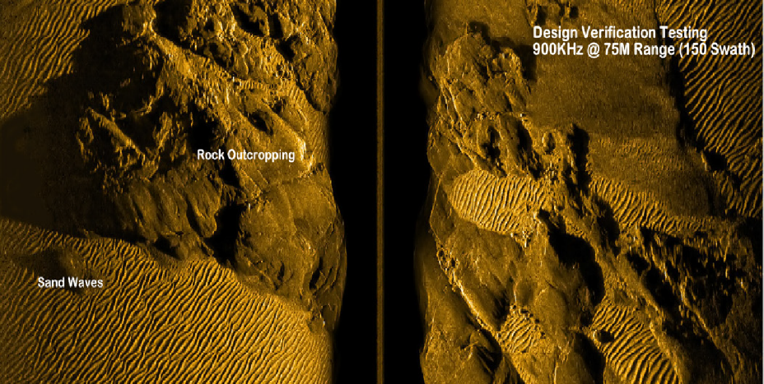

*Figure 1 – Side Scan Sonar*

**הערכה לשיחת סקר תכנון ראשוני** (PDR)

אם יש צורך, לכל סטודנט/ית בנפרד

מספר הפרויקט: _____-____20-P

שם הפרויקט:

שם המנחה החיצוני:

שם המנחה מהמחלקה:

שם הסטודנט/ית: ת.ז.:

|  |  |  |  |
| --- | --- | --- | --- |
| % | מהות | ציון | הערות |
| 100 | שיחה + דו"ח - הבנת הנושא ומהות העשייה, הבנת הצורך, סביבת היישום, הגדרת מדדים, מקורות ועבודות דומות.  הצגת התקצירים, מפרט טכני/הצעת מחקר והצעת תכנון מפורטים. |  |  |
|  |  |  |  |
|  |  |  |  |
|  | ציון סופי |  |  |

הערות: